Cub Scout Pack 313
The Family Fun Machine





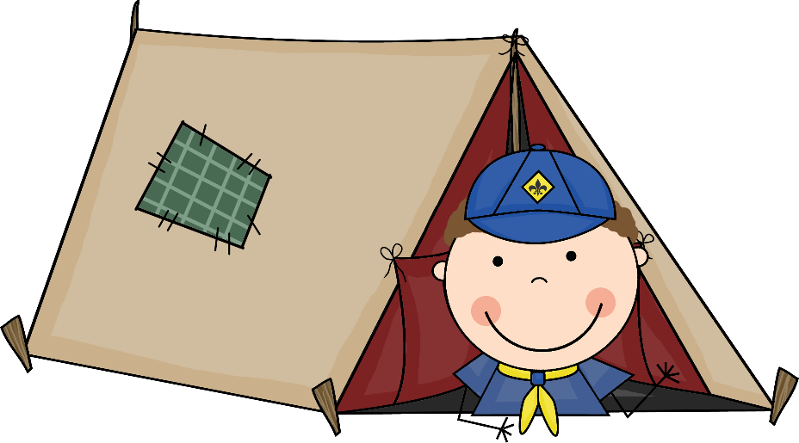


Family Information Packet

INFORMATION AT A GLANCE

My pack number is Pack 313
My pack meets at Christ Our King Presbyterian Church
10 Lexington Rd. Bel Air, MD 21014
My pack meets on 3rd Friday of the month
My den number is __________________________________
My den leader’s name is _____________________________
My den leader’s phone number is ______________________
My den leader’s email is ______________________________
My den meets on ___________________________________
My den meets at ____________________________________
My Cubmaster’s name is Andy Whaley
My Cubmaster’s email is Pack313belair@gmail.com
My Pack’s Facebook group is Cub Scout Pack 313 - Bel Air, MD
My Pack’s Website www.csp313.org
My Scouting District is Harford District
The Scout Shop is at The Festival at Bel Air
5 Bel Air S Pkwy. Bel Air, MD 21015

Welcome to Cub Scouts!

We want to welcome you and your family to Cub Scout Pack 313 – The Family Fun Machine. Our Pack serves the Bel Air area for boys in first through fifth grade (or about seven to eleven years old).


Our Pack is chartered by
Christ Our King Presbyterian Church
10 Lexington Rd.
Bel Air, MD 21014
Telephone: 410-838-4698
Website: www.christourking.net
Facebook: www.facebook.com/christourking

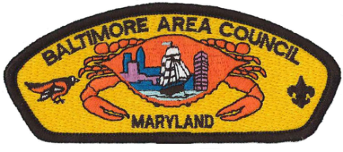
Our Pack is a member of the
Harford District
of the
Baltimore Area Council, Boy Scouts of America

This information guide is designed to help your family become acquainted with our program, what we believe, and what we expect from our Scouts, Volunteer leaders, and the Pack families. It is reviewed and updated regularly based on feedback from people just like you. If you think we missed something, let the Committee Chair or Cubmaster know and we’ll get it updated for the next printing!

Purpose of Cub Scouting

The purpose of the Boy Scouts of America is to provide, for boys and young adults, an informal educational program designed to train boys in the responsibilities of citizenship, provide growth in moral strength and character, and to enhance the development of physical, mental, and emotional fitness.

Through Cub Scouting, parents, leaders, and organizations work together to achieve the following:

- Influence the development of character and encouraging spiritual growth.
- Developing habits and attitudes of good citizenship.
- Encouraging good sportsmanship and pride in growing strong in mind and body.
- Improving understanding within the family.
- Strengthening the ability to get along with other boys and respect other people.
- Fostering a sense of personal achievement by developing new interests and skills.
- Showing how to be helpful and do one’s best.
- Providing fun and exciting things to do.
- Preparing them to become Boy Scouts.







Registration
®
®
®
®

Boys who are eligible to join Cub Scouts are:
- 6 years old and in the first grade – TIGERS
- 7 years old and have completed the first grade – WOLVES
- 8 years old and have completed the second grade – BEARS
- 9 years old and have completed the third grade – WEBELOS
- 10 years old and have completed the fourth grade – ARROW OF LIGHT

How to register your son for Pack 313
- A Cub Scout Application form must be completed in order to join Pack 313.
- A signed copy of the Pack 313 By-laws must also be submitted within one month of joining.
- Dues will also be collected when you join. The cost for new scouts is $120.00.

Meetings

There are typically two meetings a month, one Den Meeting & one Pack Meeting

Den Meetings
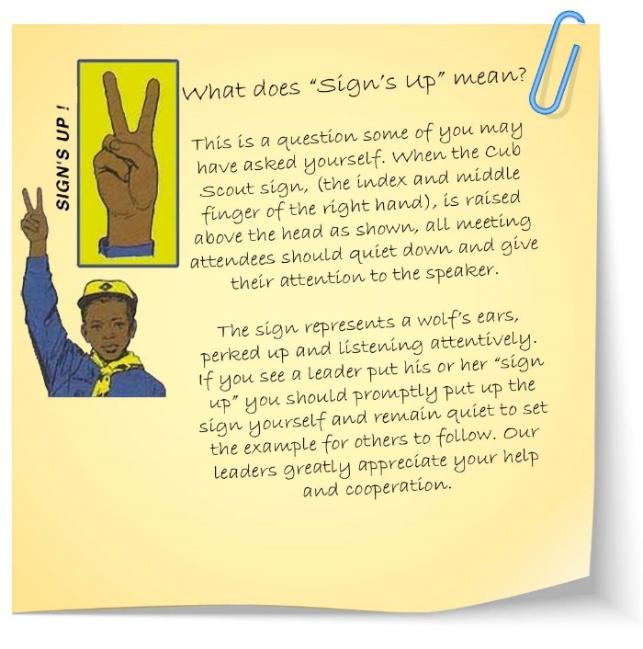
A majority of Cub Scouting happens on the Den level. Dens will meet independently at established meeting facilities and time determined by your Den Leader. Please remember that your son’s Den Leader is a volunteer putting forth his or her time and effort to help your boy ‘do his best’ to earn his badges, participate in the fun, and gain all the positive values that the Cub Scout program offers.

Pack Meeting

The regular monthly Pack meetings will be held in the Great Hall of Christ Our King Presbyterian Church in Bel Air, Maryland as listed on the Pack calendar. Parents are expected to accompany their son to the Pack Meeting and siblings are welcome. At Pack meetings, the Cubmaster will ‘do his/her best’ to make sure that each Den has a chance to display that special craft they made, song they learned, skit they’ve rehearsed, or interesting place they visited. In addition, there might be an advancement ceremony, or other themed event planned for the evening.

Uniforms
Cub Scout Uniform


New Cubs in Pack 313 who are 8 years old or younger or not yet in 3rd grade are required to purchase only the official navy blue Cub Scout shirt, neckerchief slide and belt. Pack 313 will provide the neckerchief.

New Cubs who are 9 years old or older, or in 4th grade, may purchase the official tan Cub Scout shirt and blue shoulder loops in place of the navy blue shirt.

Cubs are expected to wear their uniform to all den and pack meetings and on all outings, unless otherwise announced or arranged. This uniform is referred to as Class A. The official uniform shirt should be worn tucked in at all times.
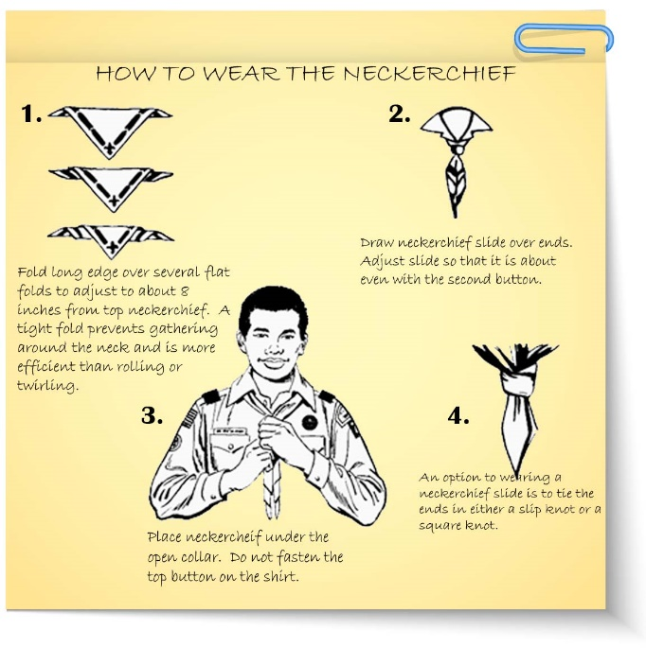
Additionally, parents and leaders will need to buy the following uniform items:


The Baltimore Area Council emblem – A multi-colored patch sewn directly below the left shoulder seam.

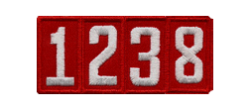
The Pack numerals – Several white numerals embroidered on a red background sewn directly below the council emblem. Our pack numerals are 313.


The Den numerals – The word DEN followed by one or more numerals embroidered in gold on a navy blue background sewn centered and touching the bottom of the U. S. flag on the right uniform sleeve. Your den leader can tell you what your son’s den numerals are.

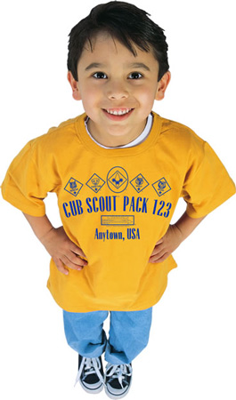
Pack T-Shirt
Pack 313 has an official t-shirt that is used when the Class A uniform is not appropriate; we call this the Class B uniform. Each Cub Scout receives a t-shirt as part of their registration fee. Talk with your Den Leader if you like to purchase additional pack t-shirts. They are approximately $10-15 dollars each for youth sizes (YXS) to each for adult sizes (A5X).

Where to buy Cub Scout uniforms, patches and handbooks


Bel Air Scout Shop in Harford County
5 Bel Air South Parkway, Suite J1009
Bel Air, MD 21015
Telephone: 410-569-2714
Hours:
Monday, Tuesday, Thursday & Friday: 10 am - 6:30 pm
Wednesday: 10 am - 7 pm
Saturday: 10 am – 3 pm
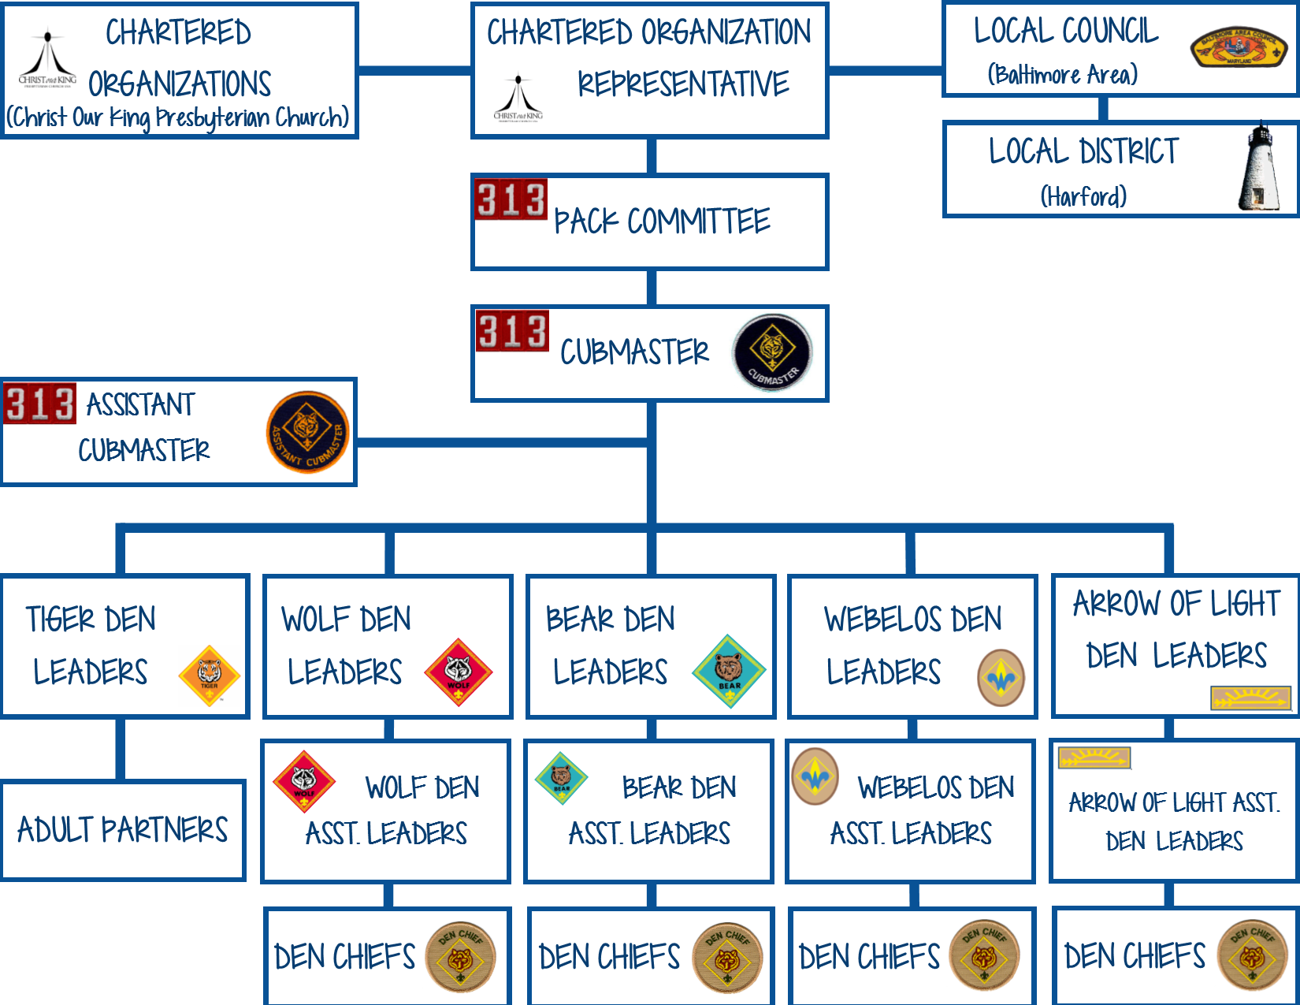
Cub Scouts/Pack Organization

Finances
Pack 313 establishes an annual budget and will set annual registration fees based upon that budget. The annual fees per returning scout for the 2017-2018 scouting year is $100.

Financial Hardship
In the event that your family is experiencing financial hardship and you need financial assistance with pack registration or den dues, please speak to the Cub Master, Den Leader or Committee Chair. All inquiries will be held in the strictest of confidence and every effort will be made to assist you and your Cub Scout.

Scoutbook
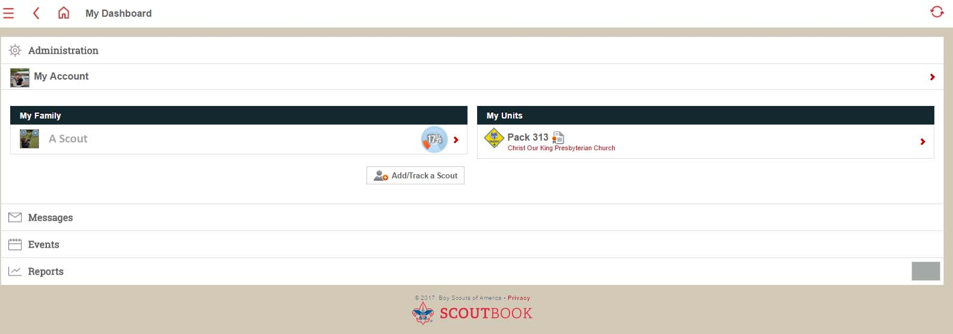
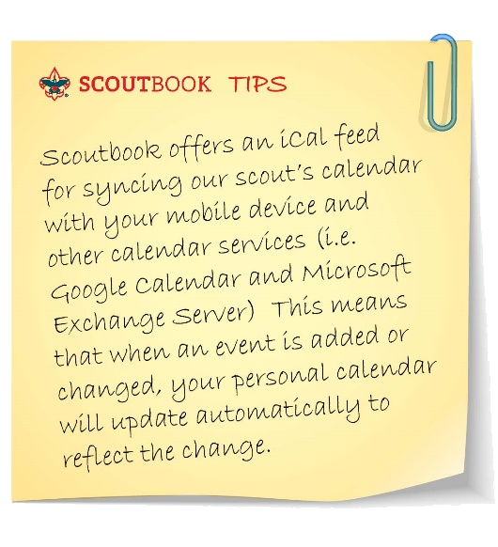
Pack 313 utilizes the online tool, Scoutbook. You and your Den Leader will use Scoutbook to track your son’s progress towards rank and his awards. Den and Pack Leaders will use Scoutbook to communicate with the parents in the pack via email and the built-in calendar.
Scoutbook makes it much easier for parents to keep up with their scout and the pack’s activities. If you have not already, you will receive an invitation to connect with your scout on Scoutbook. Please log-in at www.scoutbook.com and verify your scout’s information. You will also be able to upload a photo to use as your account’s avatar.

Website
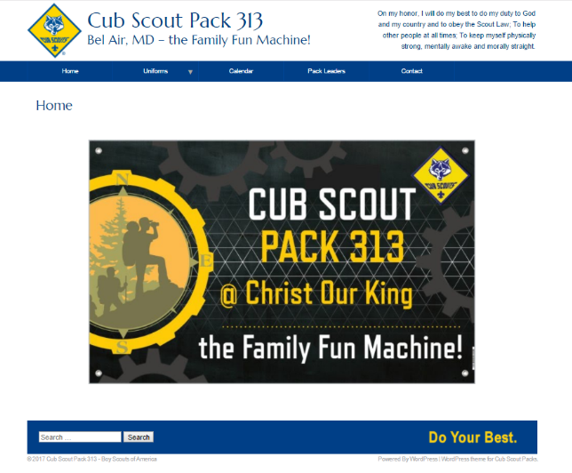
Our pack has an updated website where you can easily find information about uniforms, Pack Leaders and access to the Pack calendar. Our pack website is www.csp313.org.



Cub Scout Pack 313
2017-2018
PACK VOLUNTEER LEADERSHIP

Role | Name | Email | Phone
Pack Leadership
Pack Commissioner | Dan Williams | ltdwilliams@gmail.com | 443-900-1723
Chartered Organization Representative | Alan Cushen | keepmwell@aol.com | 443-910-8120
Committee Chair | Brian Young | votebyoung@gmail.com | 443-243-1039
Cub Master | Andy Whaley | Pack313belair@gmail.com | 734-775-4717
Assistant Cub Master (Ldr. Trng.) | Shane Sims | shane.sims@gmail.com | 706-577-3465
Assistant Cub Master (Ldr. Asst.) | Mindy Goldman | mindy@thegoldmans.com
Treasurer | Mark Saxon | msaxon78@gmail.com
Secretary | Lisa Attanasio | lmattanasio@hotmail.com
Committee Members
Advancements & Awards Chair | Jenn Denny | jndenny@gmail.com
Membership/Rechartering Chair | Rachael Sims | sims.rachael@gmail.com | 706-577-2644
Pack Meeting Coordinator | Katie Grabenstein
Photographer/Scribe | Michael Goldman | mgoldman@thegoldmans.com
Quartermaster
Service Chair (Community, Conservation, VFW)
STEM/Super Nova Coordinator
Troop 313-Pack 313 Coordinator | Dean Hansen | dean.hansen_usa@yahoo.com
Used Uniform Closet | Ramona Browne
Webmaster | Chrissy Bancells Davis | dmtheta@gmail.com
Other Committee Members
Blue & Gold Birthday Coordinator
Camping Coordinator | Kimberly Ewers
Camp Card Coordinator | Holly Shek | hshek@jhfcu.org
Day Camp Coordinator
Independence Day Parade Coordinator | Holly Shek | hshek@jhfcu.org
Popcorn Kernel (Chair) | Kimberly Plant | kimberlyhplant@gmail.com
Popcorn Show N Sells Coordinator | Jamie and William Batts  Alison Humphreys | Williambatts299@yahoo.com  azhumphreys@gmail.com
Pinewood Derby Coordinator | Will Kuchta | willkuchta@gmail.com
Scout Sunday Coordinator
ScoutSTRONG Coordinator
Scouting for Food Coordinator
Shooting Sports Award Coordinator | Igor Taran | itaran@gmail.com

Cub Scout Pack 313
2017-2018
PACK VOLUNTEER LEADERSHIP

Den Leaders
Role | Name | Email | Phone
Lions Guide A | Alison Humphreys | azhumphreys@gmail.com
Lions Guide B | Mike Bush | bushmj@comcast.net
Tiger Den 7 Leader
Wolf Den 1 Leader  Assistant Den Leader | William Batts | Williambatts299@yahoo.com | 410-459-6543
Wolf Den 3 Leader  Assistant Den Leader | Chris Rickards  Alexander Necker | Crickards7@gmail.com  adnecker@gmail.com
Wolf Den 4 Leader  Assistant Den Leader | Steve Lober | rslober@yahoo.com
Wolf Den 6 Den Leader  Assistant Den Leader | April Naylor  William Kutcha | april_naylor@verizon.net  tlrose4@verizon.net | 410-218-0085  703-283-1142
Bear Den 5 Leader  Assistant Den Leader  Assistant Den Leader | Brian Young  Holly Shek  Rob Wolfe | votebyoung@gmail.com | 443-243-1039
Bear Den 8 Leader  Assistant Den Leader | Igor Taran  Jenn Denny | itaran@gmail.com  jndenny@gmail.com | 201-310-1983
Bear Den 10 Leader  Assistant Den Leader | Ralph Bordner  Sariela Bordner | orbital.mech@gmail.com | 407-625-9182
Webelo (Jr.) Den 2 Leader  Assistant Den Leader | Ed Luberski | eluberski@gmail.com | 443-910-1569
Webelos (Sr.) Ninja Den Leader  Assistant Den Leader | Shane Sims | shane.sims@gmail.com | 706-577-3465
Webelos (Sr.) Lucky 7 Den Leader  Assistant Den Leader | Joel Gegato  Jason King | joelgegato@hotmail.com  jkinger26@gmail.com | 253-691-9093  410-804-2469

Please join the Committee/Parent Member Meeting
on the 3rd Thursdays of each month from 6:30-8:00pm
in the Great Hall @ Christ Our King Presbyterian Church (COK)
10 Lexington Road Bel Air, MD.

Important Terms to Know

AKELA: A term of endearment given to any parent, leader, or role model who does their best to help make the pack go. (In “The Jungle Book” by Rudyard Kipling, AKELA is the leader of the wolf pack who adopts and raises Mowgli, a human boy who he finds lost in the jungle.)

BYLAWS: These are the rules that all parents and scouts agree to abide by as part of Pack 313. Parents and scouts will be given by-laws upon joining the pack and are required to have them read and signed and handed back in to their leader within a month of joining the pack.

COUNCIL: A charter body of representatives from organizations operating Scouting units and members at large responsible for Scouting in a designated geographical area. Pack 313 is a member of the Baltimore Area Council.

DISTRICT: A geographical administrative unit of a council. Pack 313 is a member of the Harford District.

PACK CHARTER ORGANIZATION: A religious, civic, fraternal, educational or other group that has applied for and received a charter to operate a Scouting unit. Pack 313’s current Charter Organization is Christ Our King Presbyterian Church.

PACK CHARTER ORGANIZATION REPRESENTATIVE (COR): The VOLUNTEER ADULT responsible for maintaining a healthy relationship between the pack and its Charter organization. Pack 313’s current Charter Organization Representative is Alan Cushen

CUBMASTER: The VOLUNTEER ADULT responsible for the planning of the Pack meeting and the Master of Ceremonies at all Pack events. Pack 313’s current Cubmaster is Andy Whaley

ASSISTANT CUBMASTER: The VOLUNTEER ADULT responsible for assisting in planning of the Pack meetings and assisting the Cubmaster at the Pack meetings and other pack events. Pack 313’s current Assistant Cubmasters are Shane Sims and Mindy Goldman.

PACK COMMITTEE CHAIRPERSON: The VOLUNTEER ADULT responsible for all aspects of the Pack operations and the person who is in charge of the Pack Committee. Pack 313’s current Committee Chairperson is Brian Young.

PACK COMMITTEE: The VOLUNTEER GROUP of adults assigned various duties to formulate and conduct a well-rounded, exciting scouting program.

SECRETARY/QUARTERMASTER: The VOLUNTEER ADULT who ensures proper records are kept within the pack and supplies are inventoried and ordered. Pack 313’s current Secretary/Quartermaster is Lisa Attanasio.

TREASURER: The VOLUNTEER ADULT responsible for all aspects of the Pack finances. Pack 313’s current Treasurer is Mark Saxon.

CUB SCOUTS: Boys, ages 6 through 11, or in the first through fifth grade.

PACK: A group of dens that meet usually once a month.

DEN: A group of Cub Scouts of the same rank (grade) that meet on a regular basis. Pack 313 Dens meet monthly at a time and location determined by their den leaders.

DEN LEADERS and ASSISTANT DEN LEADERS: The VOLUNTEER ADULTS responsible for conducting den meetings. Pack 313’s current Den Leaders and Assistant Den Leaders are listed on the Pack 313 Volunteer Leadership sheet.

DEN CHIEF: An older Boy Scout, who is appointed by his Boy Scout Troop and the Cub Scout Pack to assist the leaders of a Cub Scout den with den activities.

PARENTS: THE PEOPLE THAT HELP MAKE IT ALL COME TOGETHER!
